^{31st ANNUAL}
“MFMA”
General Motors Chevrolet Presentation
Tuesday, September 10, 2024 ~ 8:00AM
Breakfast at Belvedere Banquets
1170 W. Devon at Rohlwing Road
Elk Grove Village, IL 60007
The Municipal Fleet Managers Association
Welcomes:
MinDee Richey ~ GM Envolve Government Area Sales Manager
George Tsouroullis ~ GM Envolve Emergency Vehicle Specialist
Lance Zimmerman ~ GM Envolve Medium Duty Specialist
Yuri Tello ~ GM Envolve Government Account Executive
Travis Csuti/Rob Kennedy ~ GM Envolve Account Executive Service
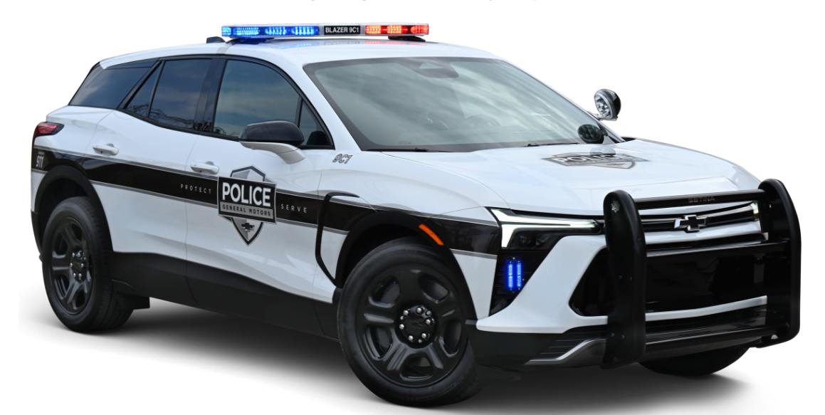
This presentation will have the latest possible information regarding the 2025 Police vehicle line up.
Possible vehicles on display: Tahoe PPV - Silverado SSV
Q & A will follow the presentation
with emphasis on police vehicle service related issues.
Product brochures will be available.
PAYMENT OF $35.00 @ IS REQUIRED IN ADVANCE
Contact Jack Gray at 224-588-6442 or jackgray500@att.net for more information.
Kindly send payment with the name of each attendee to,
MFMA c/o Jack Gray, 8380 Bridgeport Bay Circle, Mount Dora, Florida 32757-8821
Reservations and payment must be received
no later than September 6, 2024
Please, no payments will be accepted at the door.

